**Question 1:**

Write SQL code in a word document that will answer the questions below using the following two tables.

Inventory position table

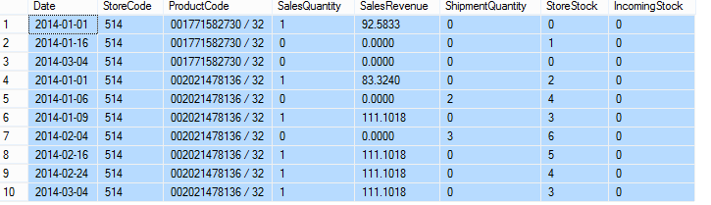

Store table

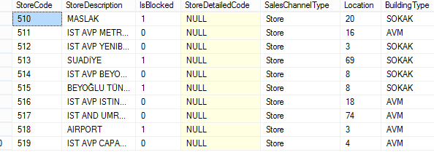

* Find the latest StoreStock for each StoreCode, ProductCode pair
* Sum sales by BuildingType
* List stores description which have sales revenue lower than 50TL in 2014 May
* In February 2014, what is the difference between the highest-selling store and the least-selling store?